**PROJECT REPORT**

**ON**

**SIMHACHALAM DEVASTHANAM RECRUITMENT AND SLOT BOOKING**

**OBJECTIVE:** The objective of the project was to design a website for Simhachalam Devasthanam with main functionalities of recruitment and slot bookings with Admin and User Login’s.

1. **RECRUITMENT**

* RECURUITEE MODULE
* ADMIN MODULE

**Recruitee Screens**

1. User Registration
2. User Login
3. Payment
4. User Dashboard
5. Status of Application
6. Result

**Admin Screens**

1. Admin Login
2. Admin Dashboard
3. Reports
4. Releasing offer letters

**FLOW FOR RECRUITMENT PROCESS**

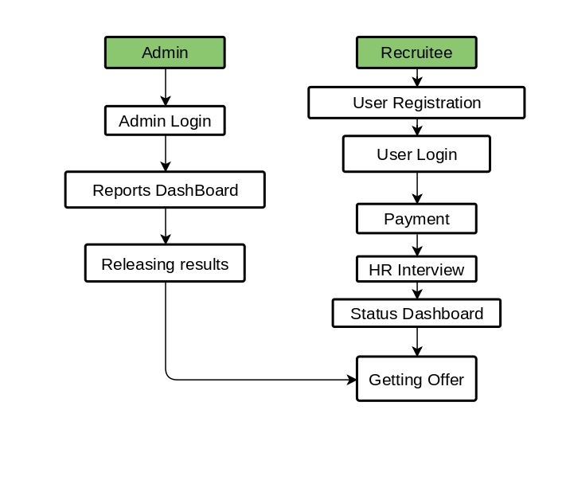

User Screens

1. User Registration Screen contains data input fields for user to enter various details used for recruitment like.

* Name
* Surname
* Dob
* Phone number
* Gender
* Address
* Educational details
* Password

1. Login Screen is used to login to the website.
2. Payment screen is used to pay the fee for application using phone number and password.
3. User dashboard Screen contains payment, status checking, and Result options to view.
4. Status Screen is used to see the application Status.
5. Result Screen get details of pass or fail.

Admin Screens

1. Admin login is used for Admin’s to login to website.
2. Admin dashboard contains various reports on recruitment details.
3. Releasing results are done by admin.
4. **DARSHAN E-SLOT BOOKING**

* DEVOTEE MODULE
* ADMIN MODULE

**Devotee Screens**

1. Devotee Registration
2. Devotee Login
3. Details and slot selection
4. Payment
5. Print ticket

**Admin Screens**

1. Admin Login
2. Release of slots

Devotee Screens

1. Devotee Registration screen contains various input fields for user details.
2. Devotee login is used by devotee to login to slot booking.
3. Details and slot selection Screen has input fields for names and number of persons and selection of slot timings for slot bookings.
4. Payment screen is used to pay for slot darshan ticket.
5. Print Ticket is a screen where we can print our slot booking ticket.

Admin Screens

1. Admin login screen is where admin can login to website.
2. Release of slots screen is where admin will release slots for booking.

**FLOW FOR SLOT BOOKING PROCESS**

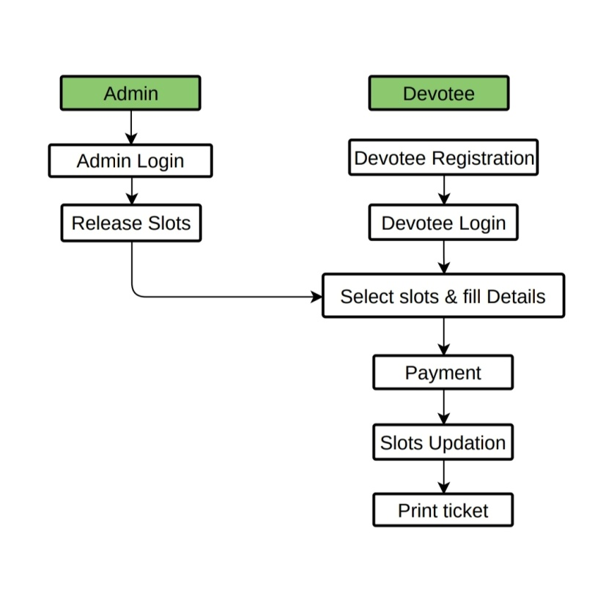

1. **DATABASE SCHEMA DESIGN**

**Login Table:**

* Phone (phone was the user Id for the Login)
* Password
* Role (user or Admin)
* IsActive
* CreatedBy
* Createddate
* UpdatedBy

After login user will directed to user Screen contains of recruitment and slot selection and admin will directed to admin screen

**Recrutee Registration Table:**

* Name
* SurName
* Phone
* Email
* Gender
* City
* Address
* Qualification
* Percentage
* Certificate
* Payment
* Result

**Devotee Slot Selection Table:**

* Phone
* NumberOfTickets
* SlotDate
* SlotTimings
* Payment
* Reference from slot selection Table

**Devotee Details Table:**

* Phone(reference from slot selection Table)(A unique id can book 4 tickets at a time)
* Names
* Age
* Gender
* Adhaar

**Slot AdminTable:**

* slotDate
* SlotTimes